# **INFOIBV 2023-2024 Block-1, Assignment-2**

Muhammed Budak (2154676)   
Süleyman Taşkın (8460051)

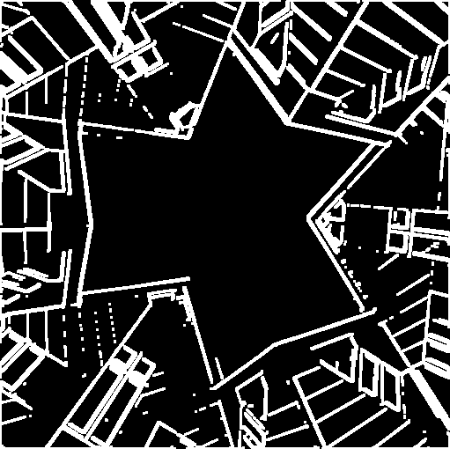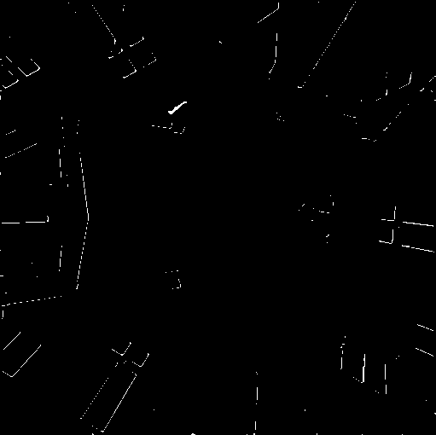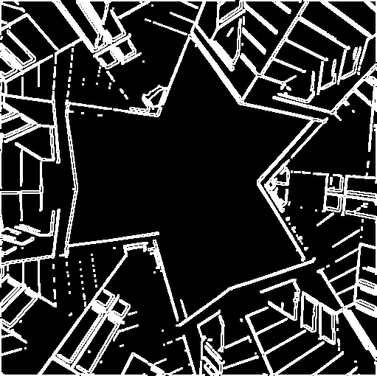

Image X (Dilated version of Image Y (Eroded version of Image Z (AND of image X with

single channel binary image single channel binary image the complement of Y)

with 3x3 kernel) with 3x3 kernel)

**Q1. The images X, Y and Z. Explain what result Z is?**

The white image parts getting ticker or thinner with dilate or erode operations respectively by structure element shape and size. This sequence of operations will result in an image where only the regions between that were expanded by dilation and shrink by erosion. This operation can be used for feature extraction or segmentation.

**Q2. Effects of structuring element shape and size when dilation operation used on a gray-scale image**

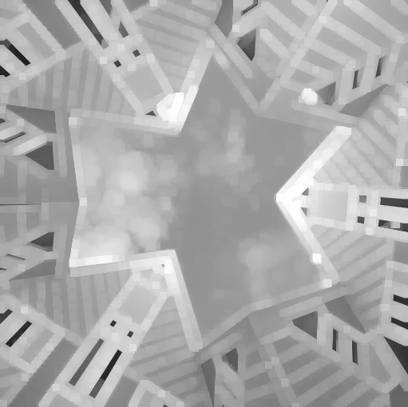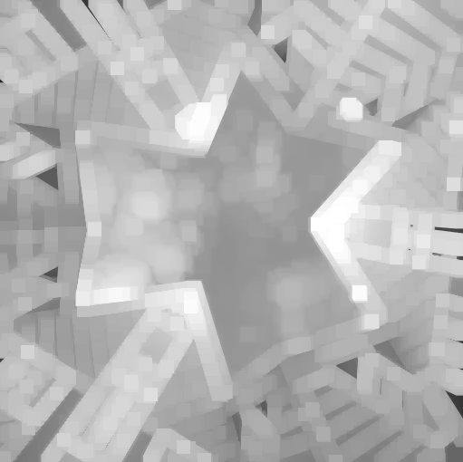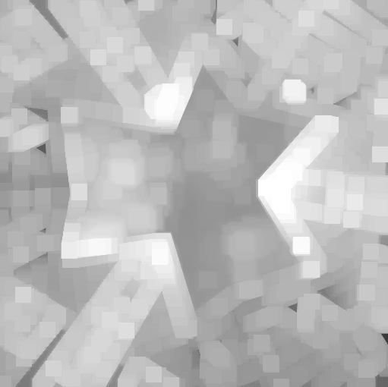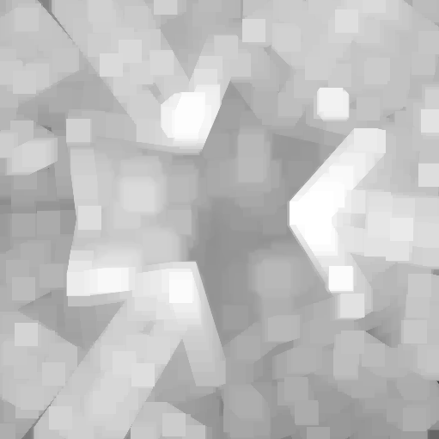

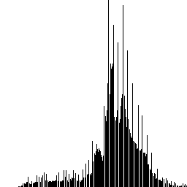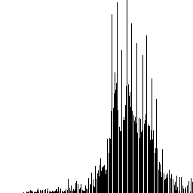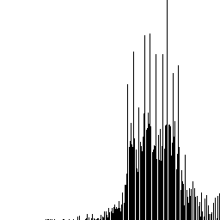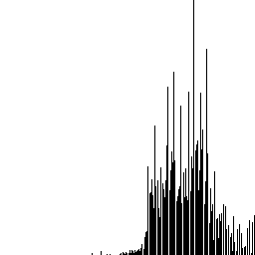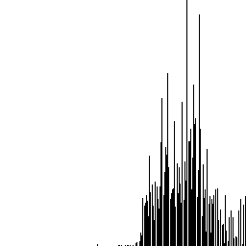

Image E1 to E5 are obtained from gray-scaled Image A in assignment 1 dilated by using square shaped structure element 3x3, 9x9, 15x15, 21x21, and 27x27 respectively. And distinct gray-scale values are obtained as 195, 182, 166, 140, and 118 and to be shown respectively.

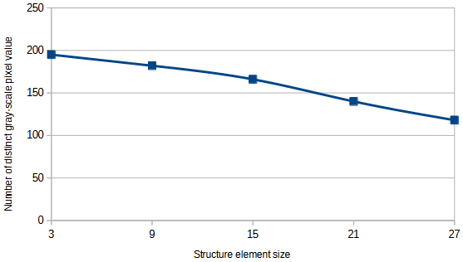

The effect of dilation with larger structuring elements is to "enlarge" or "spread" the brighter regions in the gray-scale image. We have chosen the square-shaped structure element to see a more rapid decrease of the distinct element value in all directions. If we have chosen plus shaped element we should see the effect vertically and horizontally. This operation can be used in image processing for tasks such as noise reduction, region merging, and feature enhancement, depending on the specific application.

**Q3. Effects of structuring element shape and size when opening operation used on a binary image**



Image G1 to G5 are obtained from binary image opened by using square shaped structure element 3x3, 23x23, 43x43, 63x63, and 83x83 respectively. And non-background values are obtained as 97481, 83582, 75121, 50242, and 33738 respectively.

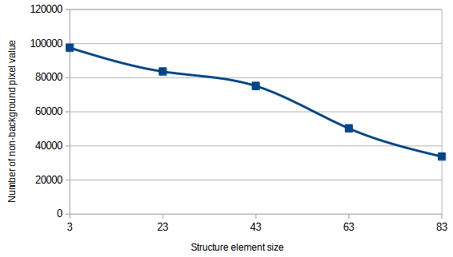

When we use an opening operation with increasing size structuring elements result: *First*, smaller structuring element (3x3) made more localized effect. We can use this small element for noise removal (smaller than the structuring element) and preserving finer details in the binary image. *Second*, larger structuring element (23x23, 43x43, and 63x63) made the opening operation has a more global impact on the binary image. It simplifies the shape of objects in the binary image. It tends to remove finer details or smaller objects and make objects appear more compact. *Finally*, very large structuring element (83x83), affected the overall structure of the binary image. Objects that were smaller than structuring element size vanished so they couldn't be regenerated by dilate operation after erode operation in opening.

In summary, the opening operation with increasing size structuring elements in a binary image can be used for morphological analysis, feature extraction, and noise reduction. Smaller structuring elements are more suitable for fine detail preservation, while larger ones are used for simplification and smoothing or finding large/largest object(s). The choice of structuring element size should align with the specific goals of our image processing application.